**Here Comes the Sun-Extra Information**

Below is a box plot of combined hourly production of the renewable sources not focued on in this analysis. The cumulative power production values from these resources are included in any chart showing “Total Renewables”, but these sources remain relatively constant so they aren’t focued on. The combined sources charted below are compiled from the hourly sum of production from biogas, biomass, small hydro, and geothermal across all years in the data set.

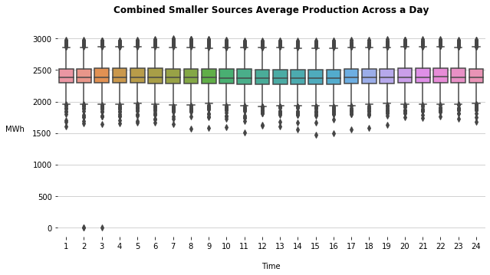

Below is a scatter chart similar to those in the presentation showing the combined production of the same sources as above. Simply showing they stay relatively constant across the year and don’t have much hourly/ seasonal fluctuation.

Below are two scatter plots for the years 2012 and 2017 showing the total renewable production across the year. The values plotted are the sum of all the renewable production values for every hour in the day. One thing to note is the difference in scale between the two plots, as well as how the trend seems to mimic wind’s yearly trend in 2012 but seems to be more like the solar trend in 2017.

Below is a box plot of the total renewable production across a day.

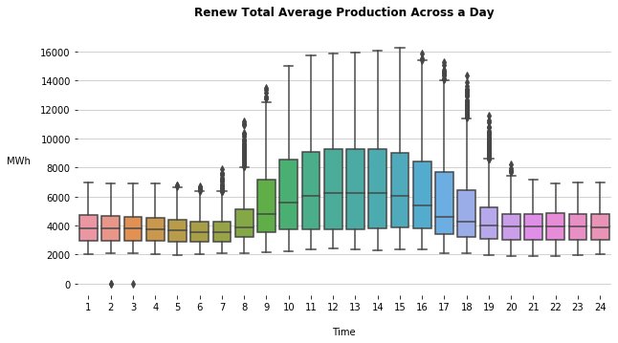

Bar chart showing increase in monthly solar production from 2012 to 2017.

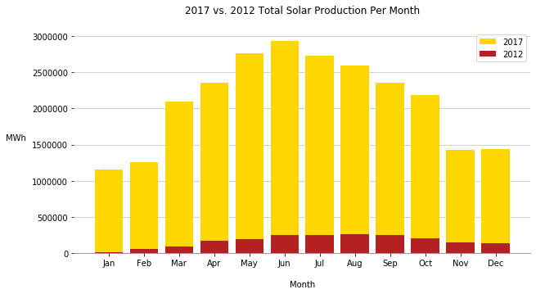

Bar chart showing increase in total renewable hourly production between 2012 and 2017.

